**ESS 474 Fall 2024**

**Remote Sensing Lab**

**Lab date: 10/11/24. Due date: 10/16/24**

**Step 3: Short Answers.**

1. Insert your exported gif here [right click on the animation and save as a .gif, then import it into your word document by Insert -> Picture]. Below this, also include a screen capture of the satellite view of your area of interest – to get this, click “satellite” on the upper right corner of the map interface on Google Earth Engine. (**3** points)



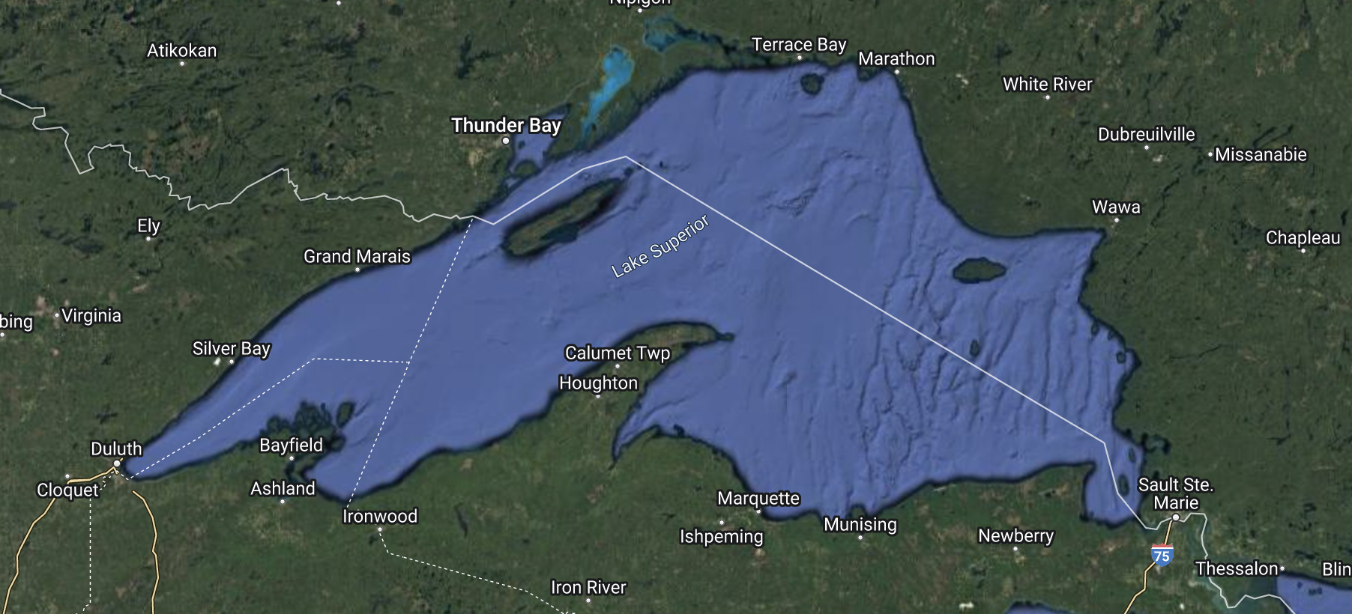

1. **Which lake and date range did you choose? (1 point)**

Lake Superior, 2017-01-01 – 2021-01-01

1. **In 4-5 sentences, describe the inter-seasonal and the spatial patterns of NDVI in the landscape surrounding your chosen lake (3 points)**

The gif begins in January 2017 and there are NDVI values below zero across most of the landscape, with sparse vegetation and exposed soils evident. Patches of snow or water can be seen in some area. As the year progresses into summer, new plant cover can be seen filling in as cold weather recedes, this can be seen in a South to North gradient. As the landscape is overtaken by darker values, spotty plumes can be seen in the lake, originating form the shorelines, with values between -1 and 0. A gradual creep and overtake of the area by sub zero values can be seen as summer progresses into fall and winter. The pattern repeats each year. In the deepest regions of the lake, the values are black rather than dark green. Indicating to me a lack of data.

1. **Google Earth Engine has access to several vegetation index timeseries other than MOD13Q1, which appears in the first line of the provided code. Try substituting “MOD13A2” for “MOD13Q1” and re-running the code.**
   1. **Which of the four types of resolution (spatial, temporal, spectral, radiometric) has changed as a result? (1 point)**

Spatial

* 1. **What impact does this change in resolution have on your ability to analyze patterns in the animation? (1 point)**

My study area is very large, and the change in resolution does not make much of a visible difference, but in a smaller area the increased resolution would make more specific analysis possible.

1. **Explore Earth Engine Data Catalog-** [**https://developers.google.com/earth-engine/datasets/**](https://developers.google.com/earth-engine/datasets/)**. In 2 paragraphs and about 200 total words, describe a research question you could pursue using one (or more) of the available datasets. Note: Clicking on any of these datasets, you will encounter remote sensing related words that will likely be unfamiliar. You are NOT expected to learn and use this vocabulary to answer this question. Simply reading through the brief description of the dataset to get a non-technical understanding of the dataset should be mostly enough (do additional internet searches if needed).**
   1. **In the first paragraph, identify your primary research question (2 points) and what dataset you would use and why (2 points). In the second paragraph discuss the scientific motivation (why is it useful to know the answer to this research question?) for your study (2 points).**

Recent hurricanes and the flooding that comes with them has punctuated the need for better climate adaptation in both coastal and mountainous areas. I would conduct a study using the land cover and cropland data sets to assist in flood risk analysis and resilience adaptation. Climatic data such as precipitation, stream flow, runoff, and evapotranspiration are important, but without the context of the landscape they are within, any analysis would fall short of accurate. These datasets would provide crucial context regarding land use, infiltration capacity, and interception.

This study would be useful because human settlement in floodplains is prolific, and with changes in weather patterns due to climate change, updated assessment of risk areas would provide crucial information to those who need it. Land use and land cover have massive impacts on infiltration, interception, and flood resiliency, so they strike me as natural places to start in assessing risk. This study could be used as an educational tool for potential homebuyers or developers, for insurance companies to determine rates, and for governments for updating zoning.

***Please upload only your answers to Step 3 to Canvas as a word document or pdf (without the text from Steps 1 and 2 or the GEE code on the following page)***